**User Manual**

**Choose a Unit**

To begin with you’ll need to choose between either the physics or functions units using the buttons at the top of the screen.

**Functions Unit**

Inside you may click on of the buttons which will then display pictures based on which button you choose.

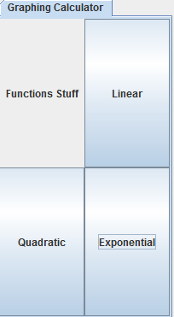

**Physics Unit**

Once inside of the physics unit you will need to choose between either the velocity or gravity demonstration in the tabbed pane.

**Velocity**

The first thing you will need to do is choose one of the four sprites from the drop down menu.

**Person Skateboard Car Rocket Ship**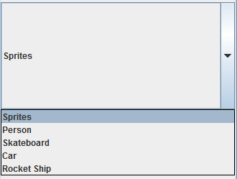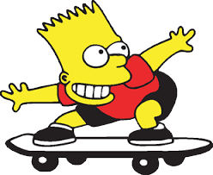

After that use the wasd keys to move your sprite across the screen. Each sprite speeds up at a different rate and when you release the key it will gradually come to a stop.

**Gravity**

Once inside the first thing you need to do is choose between one of the three planets in the drop down menu.

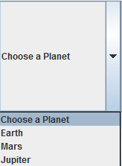

**Earth Mars Jupiter**

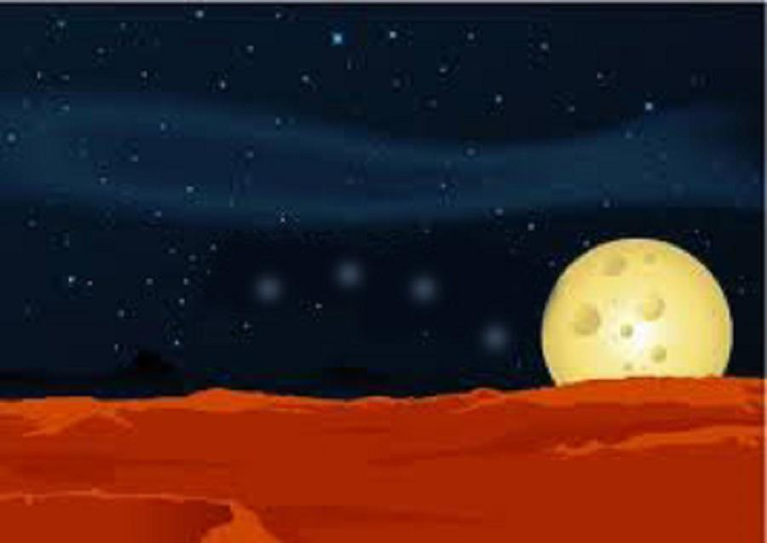

After you’ve chosen a planet you will need to choose one of the sprites in the sprites drop down menu.

**Anvil Person Leaf**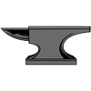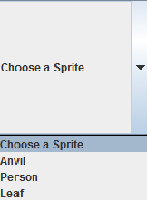leaf1.png

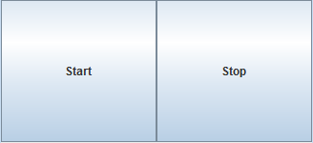 Finally you’ll need to click on the start button to make the sprite drop down the screen. When you want it to stop moving you’ll need to click on the stop button.

Each sprite has a different speed based on which sprite you choose since each will have a different weight and also based on which planet you choose since each will have a different gravity.

**Closing the program**

 Finally to exit the program you’ll need to click on the red x in the top right corner of the screen.